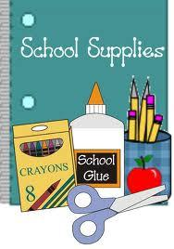 **2nd Grade Supply List 2017-2018**

|  |  |
| --- | --- |
| **Quantity** | **Item** |
| **1 Doz.** | **#2 Ticonderoga Pencils, sharpened** |
| **4** | **Folders, 2 pockets, 4 Blue/Red/Green/Yellow – durable and FIRM PLASTIC** |
| **1 box** | **Crayons, Crayola, Tuck Box of 24** |
| **1 set** | **Crayola washable markers, wide tip, classic colors, set of 8** |
| **1 box** | **Crayola classic markers, thin tip, set of 8** |
| **1** | **Highlighter, chisel tip** |
| **2** | **Elmer’s glue stick, washable, purple, .77 oz.** |
| **1 Pk.** | **Expo Dry Erase Markers, chisel point, low order, Assort. 4 pack** |
| **3** | **Composition book, marble cover, wide ruled 100 sheets,**  **(any 3 different colors)** |
| **1 Pk. of 3** | **Post-it Notes - 3in x 3in (3 pack)** |
| **1** | **Hand Sanitizer bottle - 12 fl. oz.** |